**COUNCIL ASSESSMENT REPORT**

|  |  |
| --- | --- |
| **Panel Reference** | 2019HCC013 |
| **DA Number** | DA/321/2019 |
| **LGA** | Lake Macquarie City Council |
| **Proposed Development** | Seniors Housing (Residential Aged Care Facility) – alterations and additions |
| **Street Address** | Hawkins Masonic Village, 3 Northville Drive, Edgeworth |
| **Applicant/Owner** | Planix Projects  Royal Freemasons’ Benevolent Institution |
| **Date of DA lodgement** | 7 March 2019 |
| **Number of Submissions** | Nil |
| **Recommendation** | Approval, subject to conditions of consent |
| **Regional Development Criteria (Schedule 7 of the SEPP (State and Regional Development) 2011** | General development over $30 million |
| **List of all relevant s4.15(1)(a) matters** | * State Environmental Planning Policy (State and Regional Development) 2011 * State Environmental Planning Policy (Housing for Seniors or People with a Disability) 2004 * State Environmental Planning Policy (Coastal Management) 2018 * State Environmental Planning Policy No. 19 – Bushland in Urban Areas * Lake Macquarie Local Environmental Plan 2014 * Lake Macquarie Development Control Plan 2014 |
| **List all documents submitted with this report for the Panel’s consideration** | Attachment A: Draft Conditions of Consent  Attachment B: Architectural Plans  Attachment C: Landscape Plans  Attachment D: Engineering Plans  Attachment E: Clause 4.6 Exception to Development Standard |
| **Report prepared by** | Amy Regado, Principal Development Planner |
| **Report date** | 4 September 2019 |

|  |  |
| --- | --- |
| **Summary of s4.15 matters**  Have all recommendations in relation to relevant s4.15 matters been summarised in the Executive Summary of the assessment report? | **Yes** |
| **Legislative clauses requiring consent authority satisfaction**  Have relevant clauses in all applicable environmental planning instruments where the consent authority must be satisfied about a particular matter been listed, and relevant recommendations summarized, in the Executive Summary of the assessment report? | **Yes** |
| **Clause 4.6 Exceptions to development standards**  If a written request for a contravention to a development standard (clause 4.6 of the LEP) has been received, has it been attached to the assessment report? | **Yes** |
| **Special Infrastructure Contributions**  Does the DA require Special Infrastructure Contributions conditions (S7.24)? | **No** |
| **Conditions**  Have draft conditions been provided to the applicant for comment? | **Yes** |

**Assessment Report**

**Development Application DA/321/2019**

**Proposal:** Seniors Housing (Residential Aged Care Facility) – alterations and additions

**Address:** Hawkins Masonic Village, 3 Northville Drive, Edgeworth

Lot 1 DP 222035

**Applicant:** Planix Projects

**Owner:** Royal Freemasons’ Benevolent Institution (owner’s consent has been provided)

**Lodged:** 7 March 2019

**Zoning:** R2 Low Density Residential

**Integrated Authority:** NSW Rural Fire Service

Subsidence Advisory (NSW)

**CIV:** $40,905,178 million

**Assessing Officer:** Amy Regado

**Recommendation:** Approval

**Executive summary**

This report assesses the proposal against relevant State, Regional and Local Environmental Planning Instruments and Policies, in accordance with Section 4.15(1) of the Environmental Planning and Assessment Act, 1979.

The application proposes construction of a Residential Aged Care Facility (RACF) at the site, comprising 150 care beds and ancillary facilities and works.

The site maintains an existing seniors housing development, and the development provides a well-designed building that complements the existing use of the site.

The development has demonstrated compliance with the SEPP Housing for Seniors or People with a Disability 2004 (Seniors Housing SEPP) and provides good amenity and facilities for future residents of the facility.

The site maintains existing vegetation, some of which are proposed to be removed within the development area. The application has demonstrated appropriate replanting and ecological outcomes.

The application proposes a variation to the building height standards under Clause 4.3 of the Lake Macquarie Local Environmental Plan 2014 and Seniors Housing SEPP up to 50%. The proposed variation is supported as the development has demonstrated consistency with the necessary heads of consideration under Clause 4.6 Exceptions to development standards.

The application has demonstrated appropriate visual outcomes by incorporating suitable design elements and landscaping to screen and soften the building form.

The application has demonstrated no significant impacts will occur to the local road network from the minor increase in traffic associated with the development.

The application is found to be in the public interest.

**Reasons for determination**

The development has been assessed against the matters for consideration that apply to the land to which the development application relates as outlined in Section 4.15 of the Environmental Planning and Assessment Act, 1979 as follows:

* the development meets the requirements of the Lake Macquarie Local Environmental Plan 2014 and other relevant environmental planning instruments;
* consideration has been given to proposed instruments which have been the subject of public consultation;
* the development generally complies with Lake Macquarie Development Control Plan 2014 with any variations to the controls outlined and justified within this assessment report;
* considering the likely impacts of the development on the natural and built environments, the development is considered to provide balanced and appropriate outcomes;
* the suitability of the site for the development, including characteristics and constraints of the land have been considered and it was found the land as being suitable for the development;
* matters of public interest have been taken into account in relation to social, economic and environmental outcomes.

Based on the balance of the matters considered, the development application is recommended for approval.  Details of the assessment are contained in the assessment report below.

**Community interest**

The assessment of the proposed development under Section 4.15(1) of the Environmental Planning and Assessment Act, 1979 has considered the community views. The development application was notified in accordance with the Development Notification Requirements outlined in Section 1.15 of Part 1 of Council’s Development Control Plan 2014 as adopted by Lake Macquarie City Council.

No submissions were received in response to the public notification of the development. Community views however were taken into consideration with the development being assessed against the provisions of the Lake Macquarie Local Environmental Plan 2014 and Development Control Plan 2014, both of which have been publicly exhibited and adopted by Lake Macquarie City Council.

**Site, context and development history**

The site maintains an existing seniors housing development known as The Hawkins Village which has operated from the site since 1972. The development currently accommodates 131 RACF beds and 184 independent living dwellings.

The site has an area of 17.91 hectares.

The site has frontage to Northville Drive and is bound by low scale residential development to the north and east.

Cockle Creek and associated bushland is located south and west of the site.

The site maintains native vegetation, interspersed throughout existing residential accommodation.

The site slopes down to Cockle Creek.

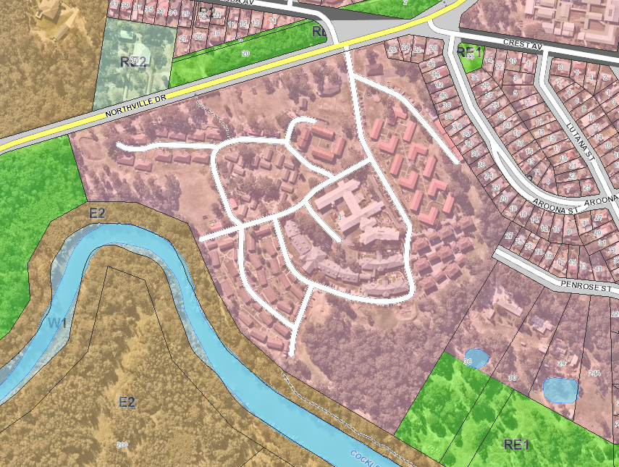

**Figure 1:** Map of site and surrounding land uses and zones

Pre-lodgement consultation was undertaken with Council in December 2018 for a RACF reflective of that proposed in the current application.

Whilst not forming part of the current application, the applicant has identified it is intended in future (and subject to separate applications) for the proposed RACF to replace existing residential care beds, kitchen, laundry, homecare and other services currently located/operating from the site.

**Proposal**

The application proposes construction of a Residential Aged Care Facility (a form of Seniors Housing) at the Hawkins Masonic Village at 3 Northville Drive, Edgeworth.

The development will operate in conjunction with the existing operations of the site as a Seniors Housing development managed by the Hawkins Masonic Benevolent Institution.

The proposal includes a three storey building shaped in a winged arrangement containing 150 beds for residential aged care and ancillary facilities.

The building includes:

* Community hub facility which includes
  + Café;
  + Hair salon;
  + Allied health rooms;
  + Multi-purpose hall
* Laundry facilities;
* Kitchen and serveries;
* Administration facilities;
* Care wings which include residential rooms, resident kitchens, lounge and dining spaces for residents of each wing

To facilitate the development, demolition of an existing village hall, four vacant independent living dwellings (known as Boronia Court), maintenance shed, portions of an existing roadway and car parking, and other ancillary structures will be undertaken.

The application also proposes site works including earthworks, stormwater infrastructure, car parking, new roadway connection to Northville Drive, maintenance shed and landscaping.

The applicants purpose for the development is to create a modern and efficient building, which is less institutional and achieves increased residential community amenity for residents.

**Detailed Assessment**

# Environmental Planning and Assessment Act 1979

Applicable State, Regional and Local Environmental Planning Instruments and Policies are detailed hereunder. Where not explicitly detailed, it is considered those instruments or policies are not relevant to the proposal.

# Section 4.15: Potential matters for consideration

## Section 4.15 (1) (a) (i) the provisions of any EPI’s

**State Environmental Planning Policy (State and Regional Development)**

In accordance with Schedule 7 and Part 4 (Regionally significant development) of the SEPP, the development has a capital investment value over $30 million and is therefore regionally significant development. The Hunter and Central Coast Regional Planning Panel will determine the development application.

**State Environmental Planning Policy (Housing for Seniors or People with a Disability) 2004**

The policy aims to encourage the provision of housing (including residential care facilities) that will increase the supply and diversity of residences that meet the needs of seniors or people with a disability, and make efficient use of existing infrastructure and services, and be of good design.

The application proposes to construct seniors housing development at the site comprising a 150 bed residential aged care facility. This facility will be operated in conjunction with the existing seniors housing development located at the site.

Seniors housing is defined under the policy as,

*residential accommodation that is, or is intended to be, used permanently for seniors or people with a disability consisting of:*

*(a)* ***a residential care facility****, or*

*(b) a hostel, or*

*(c) a group of self-contained dwellings, or*

*(d) a combination of these*

*but does not include a hospital.*

The Policy defines a residential care facility under Clause 11 as,

*residential accommodation for seniors or people with a disability that includes:*

*a) meals and cleaning services, and*

*(b) personal care or nursing care, or both, and*

*(c) appropriate staffing, furniture, furnishings and equipment for the provision of that accommodation and care,*

*not being a dwelling, hostel, hospital or psychiatric facility.*

Note, the Aged Care Act 1997 of the Commonwealth requires residential care facilities to which that Act applies to meet certain requirements.

The development includes the provision of meals (prepared on-site), 24 nursing care staff, personal care, cleaning services and the provision of furniture and furnishings to the facility. The proposal can therefore be classified as a residential aged care facility. The ongoing provision of these services is managed under the Aged Care Act 1997.

In accordance with Clause 4, the policy applies to land that is zoned for urban purposes and permits dwelling houses. The site is zoned R2 Medium Density Residential and in accordance with Lake Macquarie Local Environmental Plan 2014 (LMLEP 2014) dwelling house development is permitted in the zone. The development is permitted in accordance with Seniors Housing SEPP.

Clause 18 of the policy requires Council to impose a condition that restricts the occupation of the development for seniors and persons with a disability, and staff employed in associated with the development. This can be achieved by way of a restriction as to user registered against the title of the property. A condition of consent is proposed to ensure this outcome is achieved.

The Seniors Housing SEPP contains a number of matters of consideration / design criteria, which have been detailed in the table below.

It is noted the Seniors Housing SEPP also contains a number of provisions such as bushfire, water and sewer, neighbourhood amenity and streetscape, car parking, visual and acoustic privacy, solar access, stormwater, crime prevention, accessibility, waste management, and the like that are not detailed in the table below, these matters are detailed elsewhere in this report.

**Table 1: Seniors Housing SEPP assessment table**

|  |  |  |  |
| --- | --- | --- | --- |
| **SEPP (Housing for Seniors or People with a Disability)**  **Key Standards** | **Control / design criteria** | **Complies**  **Yes / No** | **Comment** |
| 26 Location and access to facilities | Residents must have access to:   * shops, bank service providers and other retail and commercial services that residents may reasonably require, and * community services and recreation facilities, and * the practice of a general medical practitioner.   Access must be:   * if within 400 metres   + access ways are accessible;   + is available both to and from the development during daylight hours at least once each day from Monday to Friday (both days inclusive), * if not within 400 metres   + a transport service from the site is available to residents, and   + it takes residents to within 400 metres from required services, and;   + a bus capable of carrying at least 10 passengers must be provided;   + the service is available to and from the development during daylight hours at least once each day from Monday to Friday (both days inclusive), and   + any access to the service is via accessible pathways. | Yes | The site is serviced by an existing bus route, where an existing bus stop is located directly adjacent to the proposed RACF development.  The path of travel from the development to the bus stop can achieve accessibility requirements.  The public transport service which services the bus stop (Route 268) provides direct connections to Edgeworth Town Square and Stockland Glendale Shopping Centre, which include a wide range of shops, bank service providers, retail and commercial services, library and recreation facilities and general medical services.  Services are provided to and from the site at least five times per weekday, with at least four times on the weekend (most within daylight hours).  Suitable conditions of consent can be imposed to ensure the access provisions, service frequency and capacity of transport provisions of the SEPP are met. |
| 29 Consent authority to consider certain site compatibility criteria for development applications to which Clause 24 does not apply | The site/development does not require a Site Compatibility Certificate (SCC) under Clause 24.  Where an SCC is not required, Council must give consideration to whether the development is compatible with the surrounding land uses and:   * the natural environment and the existing and approved uses of land in the vicinity; * the services and infrastructure that are, or will be available to meet the demands arising from the proposed development (particularly, retail, community, medical and transport services); * the bulk, scale, built form and character of the proposed development and impact to existing and approved uses. | Yes | The development is considered to be compatible with the surrounding land uses as follows.  Natural environment  The land is already developed for seniors housing development and the proposed development is entirely compatible with the existing and future uses of the land, and the surrounding residential lands.  It is acknowledged the application proposes tree removal across the development area (not the entire site), however suitable compensatory planting will be provided to re-establish a balanced development outcome.  Council’s Landscape Architect is satisfied with the proposed landscaping outcomes and species selection.  Services and infrastructure  The site maintains an existing seniors housing development whereby an existing level of demand for nearby retail, community, medical and transport services exists. The proposed development is considered to have an inconsequential increase in demand and such that it would not adversely impact upon the ability of these services to cater for the increase.  The development also provides new and improved community facilities (small shop, visiting consulting rooms, café, etc) on-site to cater for the development, and existing residents of the site. This will potentially reduce the demand for off-site services.  The site is provided with the required infrastructure to cater for the proposed development.  Building design  The building has been designed to reflect the existing use of the site for seniors housing, whilst respecting surrounding land uses, particularly the adjoining low scale residential zoned lands to the north-east.  The building incorporates appropriate articulation and fenestration, and incorporates distinct portions with separate roof profiles to present a reduced bulk and scale to the adjoining low density residential lands.  The building form has been designed to integrate with the natural contours of the site, which results in an elevated form as viewed from the west. Whilst elevated, the design of the building is considered to be satisfactory as the building is set in to the site away from Northville Drive, and also incorporates compensatory landscaping to screen and fragment the building form. |
| 40 Development Standards – minimum sizes and building height | Development standards to be complied with:   * The size of the site must be at least 1,000m2; * The site frontage must be at least 20 metres wide measured at the building line; | Yes | The site has an area in excess of 1000m2 and frontage in excess of 20 metres. |
| Where proposed in a residential zone where residential flat buildings are not permitted:   * The height of all buildings must be 8 metres or less; * A building that is adjacent to a boundary of the site must be not more than 2 storeys in height; * A building located in the rear 25% area of the site must not exceed 1 storey in height. | **No** | The building (not having regard to existing ground levels) has a maximum height of 11.23 metres. The building is not located adjacent to any boundary.  The building height results in a variation to the height of building standard of 3.23 metres (40.3%).  For consideration of the variation, refer to assessment under LMLEP 2014 Clause 4.6 Exception to development standards. |
| 48 Standards that cannot be used to refuse development consent for residential care facilities | Consent must not be refused for a residential care facility on any of the following grounds:   * building height: if all proposed buildings are 8 metres or less in height (and regardless of any other standard specified by another environmental planning instrument limiting development to 2 storeys) | **No** | Refer to assessment under SEPP Seniors Housing / Clause 40 Development Standards – minimum sizes and building height. |
| * density and scale: if the density and scale of the buildings when expressed as a floor space ratio (FSR) is 1:1 or less | Yes | The application proposes approximately 10 000m2 of floor area.  Given the extensive area of the site, the additional floor area would not result in the development exceeding an FSR of 1:1. |
| * landscaped area: if a minimum of 25 square metres of landscaped area per residential care facility bed is provided | Yes | The application proposes 150 beds and a landscape area of 3750m2 is required.  The application proposes a landscape area well in excess of this requirement across the site. |
| * parking for residents and visitors: if at least the following is provided:   + 1 parking space for each 10 beds in the residential care facility   + or 1 parking space for each 15 beds if the facility provides care only for persons with dementia; and   + 1 parking space for each 2 persons to be employed in connection with the development and on duty at any one time, and   + 1 parking space suitable for an ambulance. | **No** | The application proposes 150 beds for seniors. Up to 40 staff will be present on site at any one time.  The application is required to provide a total of 35 car parking spaces on site based upon the following:   * 15 spaces for seniors; * 20 spaces for staff.   An ambulance bay is also required.  The application proposes 34 new car parking spaces (basement car parking and new external car parking areas), however also proposes to remove eight car parking spaces from the site. This result in a net increase of 26 car parking spaces.  Whilst the development does not achieve the numerical car parking standard, the site maintains additional formal and informal car parking and has the capacity to cater for additional car parking, and the variation is supported. The reduction in car parking is unlikely to have adverse overflow impacts upon the local street network.  An ambulance bay is also proposed in the basement car parking area.  To further encourage alternate modes of transport, a condition of consent will be imposed for bicycle parking racks to be provided within proximity to the main entry of the development. This will encourage cycling opportunities by visitors and staff, noting staff change rooms and showers are provided within the development. |
| 55 Residential care facilities for seniors required to have fire sprinkler systems | Consent must not be granted for a residential care facility unless the proposed development includes a fire sprinkler system. | Yes | Conditions of consent can be imposed to ensure a fire sprinkler system is installed. |

**State Environmental Planning Policy (Coastal Management) 2018**

The Policy aims to manage development in the coastal zone in an integrated and coordinated manner.

The site is located within the Coastal Use Area and Coastal Environment Area.

The site is also mapped as Coastal wetland buffer which relates to wetlands associated with Cockle Creek (refer to Figure 2). No works are proposed within this area of the site and Council’s Ecologist has confirmed the development is acceptable in this regard and no further consideration of this matter is necessary.

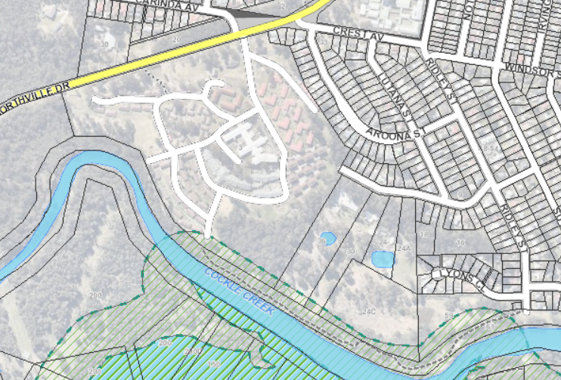

**Figure 2:** Coastal wetland buffer mapping

The development is considered consistent with the SEPP and will not have adverse impacts to the coastal zone in terms of coastal values, natural coastal processes, access to coast and foreshore areas, impact to marine vegetation, aboriginal heritage, scenic quality, etc. Specific details of these relevant matters are discussed throughout this report.

The policy also states consent must not be granted to development on land within the coastal zone unless the consent authority has taken into consideration the relevant provisions of a coastal management program that applies to the land. The site is subject to the LMCC Coastal Zone Management Plan. The Plan does not have any specific matters relating to the site and the overall objectives of the Plan would apply; as discussed, these overall objectives for development in the coastal zone have been achieved.

**State Environmental Planning Policy No. 19 – Bushland in Urban Areas**

The Policy aims to protect and preserve bushland in urban areas. As demonstrated in Figure 1, the site adjoins RE1 Public Recreation zoned lands, and the development is subject to Clause 9 Land adjoining land zoned or reserved for public open space.

The area of the site subject to the proposed development is sufficiently separated from the mapped bushland areas, and the development is consistent with the aims of the SEPP. Further, suitable conditions of consent regarding erosion and sediment control, and stormwater management can be imposed.

**State Environmental Planning Policy No. 44 – Koala Habitat Protection**

Refer to assessment under DCP 2014 Part 3 Section 2.12 Flora and Fauna.

**Lake Macquarie Local Environmental Plan 2014**

Clause 2.3 Zone objectives and Land Use Table

The development is permitted both under Seniors Housing SEPP and LMLEP 2014. The application has been applied for under the Seniors Housing SEPP. Refer to Seniors Housing SEPP within this report for further consideration of permissibility.

The site is zoned R2 Low Density Residential. The proposal is considered to be consistent with the relevant objectives of the zone as follows,

* To provide for the housing needs of the community within a low density residential environment.
* To encourage development that is sympathetic to the scenic, aesthetic and cultural heritage qualities of the built and natural environment.

The development is considered consistent with the zone objectives, in that the building form has been designed to be sympathetic to the site’s natural attributes, and the surrounding residential land uses. The development has been designed to maintain the residential amenity and nature of the low density residential within the site, and east of the site.

The development provides a seniors housing development that provides additional residential care housing options for the community.

Other proposed uses (e.g. café, small boutique / shop) are ancillary to the dominant function of the site for seniors housing, and are therefore permitted.

Clause 2.7 Demolition requires development consent

The application proposes demolition and has sought consent for these works.

Clause 4.3 Height of buildings

The site is subject to an 8.5 metre building height limit.

The application proposes a maximum building height of 12.75 metres above existing ground level. This results in a variation to the standard of 4.25 metres (50%).

For consideration of this matter, refer to assessment under LMLEP 2014 - Clause 4.6.

Clause 4.6 Exceptions to development standards

Clause 4.6 (Exceptions to development standards) of LMLEP 2014 enables variations to development standards including the heights of building within the LEP and Seniors Housing SEPP.

A separate Clause 4.6 Exception to development standard has been submitted with the application for variation to Clause 4.3 of LMLEP 2014 (Height of Buildings). The application proposes a maximum building height of 12.75 metres above existing ground level. A maximum variation to the standard of 4.25 metres (50%) is proposed, which relates to the following portions of the second floor roof (refer to Figure 3):

* southern wing: 4.25 metre exceedance;
* middle wing: 2.5 metre exceedance,
* northern wing: 1.55 metre exceedance, and
* roof, ceiling, roof mounted infrastructure and lift overrun over the central entry spine: 3.15 metre exceedance.

The building elements exceeding the building height are limited to less than 40% of the entire roof area.

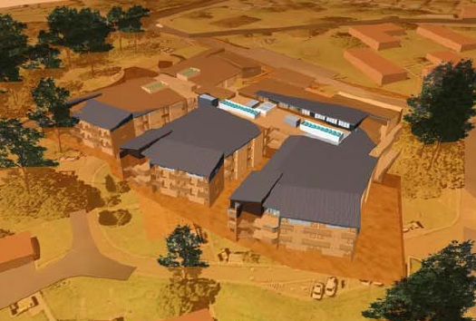

**Figure 3:** Building height variation to 8.5 metre LEP building height

A Clause 4.6 Exception to development standard has been submitted with the application for variation to Clause 40(4)(a) of Seniors Housing SEPP (Height of Buildings). The proposed building (not having regard to existing ground levels) has a maximum height of 11.23 metres. A variation to the standard of 3.23 metres (40.3%) is proposed, which relates to the following portions of the Second Floor roof (refer to Figure 4):

* southern wing: 2.45 metre exceedance;
* middle wing: 0.7 metre exceedance, and
* roof, ceiling, roof mounted infrastructure and lift overrun over the central entry spine: 3.23 metre exceedance.

The building elements exceeding the building height are limited to less than 40% of the entire roof area.

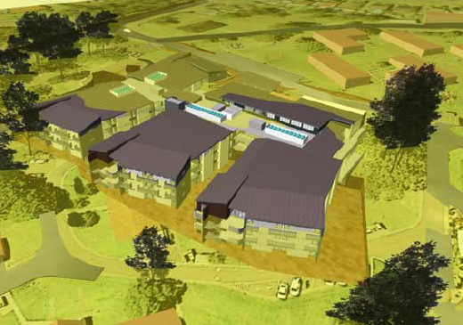

**Figure 4:** Building height variation to 8 metre SEPP Seniors Housing building height.

Development consent must not be granted for development that contravenes a development standard unless the consent authority has considered a written request from the applicant that seeks to justify the contravention of the development standard by demonstrating,

1. that compliance with the development standard is unreasonable or unnecessary in the circumstances of the case, and
2. that there are sufficient environmental planning grounds to justify contravening the development standard.

The applicant’s written variations have argued the objectives of the building height development standards are achieved notwithstanding non-compliance with the applicable standards. In particular, the written variations have argued the height of the building is appropriate for its location and is a high quality urban form (clause 4.3 LMLEP 2014) and sits comfortably in the low-density residential zone (Seniors Housing SEPP) for the following reasons:

* the height of the building is consistent with the character of existing built form within the existing site;
* the building has been designed to present as single storey to the main site entry and adjoining residences;
* the building has suitable separation from existing residences on the site, and adjoining sites, and does not have any adverse amenity impacts on existing residents including solar access and visual privacy;
* the higher elements of the building are internalised within the site, and the elements that exceed the building height would not have unreasonable visual or amenity impacts;
* the overall ridgeline of the building sits below the adjacent vegetated ridgeline to the north of the site and does not visually affect the natural ridgelines of the area;
* the building will be visually screened by existing and proposed mature vegetation to Northville Drive, this assists in minimising the appearance of height, bulk and scale when viewed from Northville Drive;
* extensive landscaping will be planted around the building to soften and visually fragment the building;
* the additional height reduces the footprint of the building and enables the retention of open space and existing vegetation within the development area;
* the building steps with the existing contours of the development area and the extent of cut has been deliberately minimised; this has resulted in some of the height exceedances;
* the design facilitates concealed basement car parking and loading dock areas;
* the building has been designed into articulated wings that reduces building bulk and mass;
* the building has been designed with appropriate floor to ceiling heights to provide good amenity to residents’ and communal areas, and
* the pitched roofs, which in part, exceed the maximum building height have been designed to provide screening of roof mounted infrastructure, thus achieving quality aesthetic and visual outcomes.

Council consider the applicant’s clause 4.6 variations have articulated appropriately that compliance with the development standard is unreasonable or unnecessary in the circumstances of the case, and there are sufficient environmental planning grounds to justify contravening the development standard.

In consideration of the clause 4.6 variations, Council have considered the development will be in the public interest because;

* it is consistent with the objectives of the building height standards; and
* is consistent with the objectives of the R2 Low Density Residential zone.

Consideration also needs to be given to whether the variation raises any matter of significance for state or regional environmental planning, and the public benefit of maintaining the standard.

The objectives of the clause 4.3 height of buildings in LMLEP 2014 are to ensure the height of buildings is appropriate for their location, and to permit building heights that encourage high quality urban form.

The objectives of clause 40(4)(a) 40 development standards in Senior Housing SEPP are not explicitly stated. In the absence of clear objectives, it is assumed the building height controls aim to maximise amenity for seniors, whilst ensuring the building sits comfortably in a low-density residential landscape.

For those reasons specified above by the applicant, the development is consistent with the separate building height standards. Particularly, the building height variation would be unperceivable in the context of the overall building form, and the variation is considered minor and not have adverse visual or amenity impacts.

With respect to the development being consistent with the objectives of the zone, as previously discussed the development is consistent with the R2 Low Density Residential zone as it provides a building form designed to be sympathetic to the site’s natural attributes, and the surrounding residential land uses.

The development is designed to maintain the residential amenity and nature of the low density residential within the site, and east of the site.

The development provides a seniors housing development in a well-serviced location, co-located with existing seniors housing to provide additional residential care housing options for the community.

In this regard, the development is consistent with the objectives of the building height standards and zone objectives and is in the public interest.

The variation does not raise any matters of state or regional significance. Further, there is no public benefit in maintaining strict compliance with the building height standard given no unreasonable impacts result from the variation.

As the consent authority for the development application, the Hunter and Central Coast Regional Planning Panel have delegation to determine the clause 4.6 variations.

Clause 5.10 Heritage conservation

Refer to assessment under DCP 2014 Part 3 Section 2.15 Aboriginal heritage.

Clause 7.1 Acid sulfate soils

Refer to assessment under DCP 2014 Part 3 Section 2.6 Acid sulfate soils.

Clause 7.2 Earthworks

Refer to assessment under DCP 2014 Part 3 Section 4.14 Cut and fill.

Clause 7.3 Flood planning

Refer to assessment under DCP 2014 Part 3 Section 2.8 Catchment flood management and 2.9 Lake flooding and tidal inundation (incorporating sea level rise).

Clause 7.7 Development on sensitive Aboriginal landscape areas

Refer to assessment under DCP 2014 Part 3 Section 2.15 Aboriginal heritage.

Clause 7.21 Essential services

This clause states development consent must not be granted unless Council is satisfied essential services are available to the development or adequate arrangements have been made to make them available when required.

Seniors Housing SEPP also contains provisions for sites to be serviced by water and sewer.

Documentation confirming the development requires the installation of a new electrical kiosk substation has been provided. To ensure this necessary infrastructure is incorporated into the development and does not have adverse streetscape impacts, a condition of consent is recommended.

The documentation also confirms the site has sufficient servicing of reticulated water for residential use and firefighting purposes.

The application was submitted to Hunter Water Corporation (HWC) prior to lodgement. Hunter Water identified water and sewer connection is available to the site, and identified upgrading will be required to facilitate the development.

For consideration of stormwater drainage and vehicle access refer to assessment under DCP 2014 Part 3 Section 2.7 Stormwater Management and Section 4.7 Traffic and Transport.

## Section 4.15 (1) (a) (ii) the provisions of any draft EPI

No draft EPI’s apply to the development and/or site.

## Section 4.15 (1) (a) (iii) DCP’s

**Lake Macquarie Development Control Plan (DCP) 2014**

Part 3 – Development in Residential Zones

2.1 Site analysis

A site analysis plan and documentation was submitted with the application.

SEPP (Housing for Seniors or People with a Disability) also contains provisions for site analysis documentation.

2.2 Scenic values

A Visual Impact (VIA) Assessment has been submitted, which includes photomontages of the development as viewed from Northville Drive (east and west).

The VIA identifies whilst the building is of a larger scale and height than existing on site, the building form is suitably separated from adjacent dwellings and is suitably screened and softened by landscaping from major public view points (Northville Drive).

The building has been stepped with the contours of the development area, which further minimises perceived building height and better integrates the building to the surrounding development. In particular, the design of the building to the sites topography results in the building presenting as single storey to the main site entry at Northville Drive.

Council’s Landscape Architect is supportive of the development and visual impact, subject to the proposed landscaping being implemented, a condition of consent is recommended to ensure the landscape outcomes are achieved.

2.3 Geotechnical

A geotechnical report has been submitted.

Council’s Engineer supports the report and has recommended conditions of consent to ensure the recommendations of the report are implemented.

2.4 Mine subsidence

The application was referred to Subsidence Advisory NSW (SA NSW) during assessment of the application. SA NSW supports the development and provided written and stamped General Terms of Approval (GTA’s).

2.5 Contaminated land

A Preliminary Site Investigation for contamination has been submitted.

Council has reviewed the report and supports the development, subject to conditions of consent regarding remediation and validation of the land.

2.6 Acid sulfate soils

An Acid Sulfate Assessment has been submitted with the application. The documentation confirms no acid sulfate soils are present within the development footprint.

2.7 Stormwater management

A stormwater management plan has been submitted with the application. The plan includes:

* capturing of roof water and direction to on-site detention tank via downpipes;
* installation of on-site detention tank, including 50KL rainwater tank capacity;
* reuse of captured rainwater for landscaping purposes; and
* pit and pipe drainage to new vehicle access, and to capture existing roadway drainage and direct around the building.

Council has reviewed the design and is supportive of the stormwater management scheme.

SEPP (Housing for Seniors or People with a Disability) also contains requirements for stormwater management. The proposal complies with these requirements by controlling and minimising impacts of stormwater runoff to adjoining properties and receiving waters, and providing stormwater detention and re-use.

2.8 Catchment flood management and 2.9 Lake flooding and tidal inundation (incorporating sea level rise)

The site is identified as being subject to lake and catchment flooding associated with Cockle Creek; located at the rear of the site.

The building platform and access roads are located well above and away from Cockle Creek and are free from flooding constraints.

2.10 Natural water systems

The development achieves sufficient separation from Cockle Creek to mitigate any impacts to the waterway.

The development has also incorporated suitable stormwater management controls to ensure Cockle Creek is not impacted by the development.

2.11 Bushfire

The site is bushfire prone. Bushfire threats comprise vegetation downslope to the south and west of the site.

A Bushfire Assessment Report has been submitted.

The application was referred to NSW RFS as Integrated Development (Seniors Housing is captured as a special fire protection purpose). NSW RFS supported the development in granting a Bush Fire Safety Authority and providing General Terms of Approval in relation to Asset Protection Zones (APZs), water and utility provision, access, evacuation plan, construction requirements, and landscaping requirements.

The above is achievable within the development.

SEPP (Housing for Seniors or People with a Disability) also contains requirements for bushfire outcomes. This includes the need to consider surrounding land uses and population groups and the capacity of existing facilities and roadways to cater for evacuation during a bushfire event. The policy requires consultation with the NSW RFS. These outcomes have been addressed by way of referral to the NSW RFS as detailed above.

2.12 Flora and fauna and 2.13 Preservation of trees and vegetation

A Biodiversity Assessment Report and Arborist Report have been submitted.

The Arborist Report identifies that 36 trees are proposed to be removed (refer to tree removal and retention plan) due to their location within the building footprint (including earthworks and roadworks) or poor health. The majority of trees to be remove comprised planted landscape species such as bottlebrushes. Tree protection zones (TPZ) will be implemented for any trees to be retained. No hollow bearing trees are proposed for removal.

The Biodiversity Assessment Report identifies the site does not contain any threatened fauna species, however contains one threatened flora species (planted *Eucalyptus nicholii*), and one threatened ecological community (TEC) (Lower Hunter Spotted Gum Ironbark Forest).

The developments APZ will also encroach into the TEC Lower Hunter Spotted Gum Ironbark Forest. However this area is already in a managed state and no further tree removal is required; maintenance of the existing ground cover is required.

The report concludes the development will not have a significant effect on any threatened species, endangered communities, or their habitat, and provides the following recommendations:

* landscaping and replacement tree planting within the site is to reflect locally occurring native species commensurate with Lower Hunter Spotted Gum – Ironbark Forest, and
* installation of erosion control measures to reduce temporary erosion and sedimentation risks to adjacent TEC vegetation.

With respect to koala habitat, the report confirmed the trees within the development area do not constitute potential koala habitat.

Council’s Ecologist is satisfied with the proposal and confirmed the conclusions and recommendations within the Biodiversity Assessment Report are supported. Conditions of consent are recommended to ensure the implementation of the recommendations.

Council’s Arborist is satisfied with the Arborist report submitted and recommendations made within the report. Conditions of consent are recommended to ensure implementation of the recommendations of the report.

2.15 Aboriginal heritage

The site is mapped within Council’s Sensitive Aboriginal Landscape Area.

Council’s Heritage Planner has identified the proposal is for the replacement of building form within an existing disturbed area of the site. The proposal is also located sufficient distances from any identified sites.

As a precautionary approach, the officer has recommended a condition of consent regarding legal responsibilities of the developer regarding the discovery of an Aboriginal relic, should it occur.

2.17 Social impact

Council’s Social Planner is generally supportive of the development and acknowledges the social benefit the development will have on the ageing demographic of the Lake Macquarie. The officer has recommended temporary community facilities are provided within the site until the completion of the new facilities. This can be achieved by the imposition of a condition of consent.

2.18 Economic impact

The development is a permitted form of development for the zone, and thus provides an expected development outcome.

Whilst the value of the development exceeds $5 million, it is considered an economic impact assessment is not necessary in this instance as the proposal reflects the existing development of the site.

2.20 Services

Refer to assessment under LMLEP 2014 Clause 7.21 Essential services.

3.1 Streetscape, 3.6 Building bulk and 3.8 Roofs

The site has extensive frontage to Northville Drive, internal roadways and existing residences. Therefore, presentation of all aspects of the building form and site are critical.

The proposal provides acceptable streetscape outcomes. The building has been designed to reflect the existing use of the site for seniors housing development, and current building trends for RACF development.

In particular:

* a sufficient setback is provided to Northville Drive to mitigate potential streetscape impacts. Existing mature vegetation and additional landscaping will be provided within the setback to ensure the building form and bulk is visually fragmented;
* the building has been designed to account for the contours of the development area, which results in a single storey building form being presented to the internal roadway (Poplar Drive) and the adjoining residential land uses.
* the building has incorporated a distinct and well-designed entry statement (including variety of activities associated with the Community Hub) that addresses the internal roadway;
* the building incorporates distinct wings with separate roof pitches to present a reduced bulk and scale to the roadway adjoining residences within the site;
* openings, gardens and windows have been orientated to all façades of the building;
* due to the levels of the site, and earthworks proposed the building will be recessed as viewed from the north;
* new car parking and the loading dock have been located beneath the building and such they will not be visible to the streetscape;
* the building provides variation in materials and colours to provide visual interest, and
* appropriate site landscaping has been provided around and within the building to break up building mass and provide internal amenity. Where infrastructure or vehicle access/car parking areas are within the streetscape, appropriate landscape screening has been provided.

SEPP (Housing for Seniors or People with a Disability) also contains requirements for streetscape outcomes. This includes the recognising existing or desired character, appropriate building bulk to minimise amenity impacts, appropriate scale for surrounding context, siting building form to land form and providing appropriate landscaping outcomes. The development successfully achieves these measures.

3.2 Street setback

The application proposes a street setback of over 40 metres to Northville Drive. This setback incorporates existing mature vegetation, and will be augmented with further landscaping.

The setback is larger than the street setback provided to the existing community building.

The setback is considered appropriate as sufficient setback from the street is provided to ensure an appropriate bulk and scale of the building is achieved when viewed from the street.

3.3 Side setback

The application proposes a side setback of over 100 metres to eastern and western boundaries. These setbacks incorporate existing development within the site.

The side setbacks are considered appropriate.

3.4 Rear setback

The application proposes a side setback of over 100 metres to eastern and western boundaries. These setbacks incorporate existing development within the site.

The side setbacks are considered appropriate.

3.5 Site coverage

Refer to assessment under SEPP (Housing for Seniors or People with a Disability) Clause 48 Standards that cannot be used to refuse development consent for residential care facilities (floor space ratio).

3.9 Views

The site is benefitted by distant views to the west of Mount Vincent and the Watagan Mountain range.

Due to the nature and location of surrounding residential development, no significant views within the surrounding locality will be impacted upon by the proposed development.

3.10 Solar access and orientation

The development will not overshadow any existing dwellings within the site.

With respect to solar access within the development, appropriate levels of solar access is achieved to rooms, communal living spaces (internal and external) and spaces within the Community Hub. Whilst some spaces may not receive optimal solar access, the variety of areas provides options for residents.

To protect western facing rooms from hot afternoon sunlight, screening will be required to western facing boundaries. This will be achieved through the imposition of conditions of consent.

SEPP (Housing for Seniors or People with a Disability) also contains requirements for solar access.

3.11 Energy efficiency and generation

The development will be required to comply with Section J of the NCC whereby energy efficiency requirements apply.

4 Visual privacy

Visual privacy between rooms will be achieved by window treatments included as part of the facility fit out. The achievement of visual privacy is inherent to the development proposed.

Visual privacy to adjoining residences within the site has been achieved by way of separation.

Suitable separation is provided to any residences on adjoining lands, and no overlooking opportunities exist.

SEPP (Housing for Seniors or People with a Disability) also contains requirements for visual privacy.

4.1 Acoustic privacy

An Acoustic Report has been submitted with the application.

The report identifies acoustic amenity can be achieved to future and existing residents within the site, and on adjoining lands, subject to the implementation of the following recommendations:

* installation of specific glazing;
* use of specific materials to achieve required ratings for walls (external and internal) and roofing;
* enclosing mechanical services and installing louvers and attenuators to comply with residential night time criteria;
* use of low-noise tracks and motor system for roller doors;
* signage limiting speed limit of new car parking area to maximum 10km/h;
* installation of acoustic fencing to loading dock and new access;
* limitation of amplified music in the Community Hub between 8am and 8pm.

The Acoustic Report and recommendations will be included as conditions of consent.

SEPP (Housing for Seniors or People with a Disability) also contains requirements for acoustic privacy. The proposal complies with these requirements by ensuring appropriate noise levels are achieved within residential rooms.

4.2 Landscape area

Refer to assessment under SEPP (Housing for Seniors or People with a Disability) / Clause 48 Standards that cannot be used to refuse development consent for residential care facilities.

4.3 Landscape design

Landscaping plans have been submitted with the application demonstrating landscaping to the perimeter of, and within the building to provide softening/screening and amenity.

This plans include:

* native tree and understorey planting along the Northville Drive frontage to assist in visually screening the building, and supplement the existing TEC;
* native tree planting to the new access road to assist in visually screening the access, and increase amenity;
* native tree and understorey planting around the building, particularly to the western façade to assist in visually screening the building and provide amenity;
* retention of existing visually significant trees to the south-east of the building for visual and amenity purposes, and
* internal courtyard planting which include non-native species best suited for their ornamental purposes and positioning in a shadowed environment. These areas are not significantly visible externally;

Landscaping has taken into account bushfire restrictions that apply to the development and site.

Council’s Landscape Architect is supportive of the development and landscaping outcomes. The proposed landscaping outcomes will be achieved by way of conditions of consent and approved plans.

4.5 Front fences and 4.6 Side and rear fences

The application proposes erection of the following fencing in association with the development:

* safety fencing to segregate the entry courtyard from the roadway;
* 1.8 metre high security fencing to proximity of building to delineate private and public areas;
* fencing to the children’s play area;
* 1.8 metre high acoustic fencing to loading dock and new access, and
* lapped and capped fence to western family gathering function area.

Limited details of the fencing materials have been provided. No objection is raised to the erection of fencing in these locations, and conditions of consent will be imposed requiring details of the fencing to be submitted to Council for approval prior to the issue of the first Construction Certificate (CC).

4.7 Traffic and transport and 4.9 Design of driveways

The development is provided with access to Northville Drive via an existing entry/exit.

The application also proposes construction of a new entry/exit to Northville Drive further west of the existing access.

A Traffic Impact Assessment has been submitted to support the proposed development, and new access. The report confirmed the proposal will result in a small increase in traffic, however this will not impact on the efficiency or effectiveness of the surrounding road network.

The report provides a breakdown of the expected traffic volumes as shown in Figure 5.

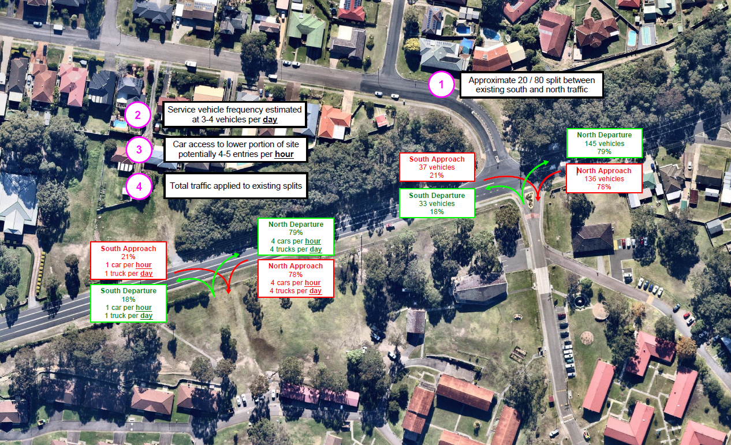

**Figure 5:** Traffic breakdown of existing access and new access

The report also identifies:

* The new access serves as a secondary access, and will largely be used for servicing and deliveries, and
* Servicing is to be undertaken with 3-4 vehicles per day, including food, beverages, laundry and waste. Servicing will be undertaken beneath the building within the loading dock.

Council’s Development Engineer is satisfied with the access and sight distances to/from Northville Drive.

Council’s Traffic Engineer has reviewed the potential impacts of the development to the local road network and is satisfied with the development.

A basic right turn treatment is required for the development with conditions of consent proposed requiring data collection to be undertaken of the actual usage (vehicle and pedestrian) of the new entrance. Where specific thresholds are exceeded, the condition will require the intersection to be upgraded to a CRT.

Existing pedestrian footpaths within the site (and adjacent to the entrance of the RACF) provide access to a bus stop within the site, and bus stops at the Northville Drive frontage of the site.

4.8 Design of parking and service areas

The site maintains existing car parking scattered throughout the site.

The application proposes construction of additional car parking at the site comprising basement car parking, an extension to an existing car parking area opposite the RACF, and an extension to the existing car parking area adjacent to the medical centre.

Servicing is proposed within the loading dock in the basement car parking area. The loading dock provides capacity for small or medium rigid vehicles, and waste collection vehicles up to 10 metres in length. The ambulance bay is also catered for within this area.

Council’s Development Engineer is satisfied with the parking and service area design and has confirmed the internal driveway and car parking and service area comply with Council’s requirements and the applicable Australian Standards.

4.10 Motor bike parking and bicycle storage

Refer to assessment under SEPP (Housing for Seniors or People with a Disability) Clause 48 Standards that cannot be used to refuse development consent for residential care facilities.

4.11 Car parking rates

Refer to assessment under SEPP (Housing for Seniors or People with a Disability) Clause 48 Standards that cannot be used to refuse development consent for residential care facilities.

4.12 Non-discriminatory access

An Access Report has been submitted with the application.

The report identifies all requirements of the applicable Australian Standards are achievable with the development and specific details can be resolved at CC stage.

Council are satisfied with the proposed accessible outcomes and confirmed the premises is capable of complying with AS 1428.1 and the Premises Standard (which will be demonstrated at CC stage).

Councils’ Ageing and Disability Services Officer has also recommended additional best practice conditions (such as installation of hearing augmentation system in the hall space) which will be imposed upon the consent.

SEPP (Housing for Seniors or People with a Disability) also contains requirements for accessibility. The proposal complies with these requirements by having pedestrian links that provide access to public transport services or local facilities.

4.13 Safety and security

A CPTED report has been submitted with the application.

The report identifies the following findings and recommendations:

* building use and design achieves suitable surveillance (natural, passive and technical);
* fencing and other access control measures (swipe card access) will be provided to control access to/within the building;
* signage to be erected to direct paths of travel and also restricted areas of the site;
* appropriate landscaping and lighting implementation and maintenance.

Council officers are supportive of the proposal and support the recommendations of the CPTED report.

SEPP (Housing for Seniors or People with a Disability) also contains requirements for crime prevention. The proposal complies with these requirements by achieving appropriate surveillance.

4.14 Cut and fill

Development should minimise the extent of earthworks, stormwater infrastructure and retaining structures and associated costs. Cut and fill should only occur within building and car parking footprints and be in accordance with the table below.

The application proposes up to six metres of excavation, which relates to the new basement vehicle access, Road 2 and the building itself (eastern portion). Excavation for Road 1 is limited to less than one metre.

Filling works are also proposed up to a maximum of 1.4 metres, which relates to Road 1, and the building (south-western portion).

Earthworks are generally located within the building footprint and are retained with integrated retaining walls. Where external to the building footprint, earthworks have been battered (basement access), or will be appropriately retained and landscaped (Road 2 and retaining adjacent to Masters Drive). Given the majority of earthworks relate to cut, the building form will be recessed into the site and impacts to the streetscape (public and internal) of any retaining walls is minimised. Suitable landscaping will also be undertaken adjacent to any external retaining walls to further soften/screen any views to external retaining structures.

Council’s Engineer has reviewed, and is supportive of the proposed earthworks.

5.1 Demolition and construction waste management

The application proposes demolition and construction works and wastes will be generated.

To ensure that any wastes are appropriately managed, a suitable condition of consent will be imposed.

5.2 Waste management and 5.4 Liquid trade waste and chemical storage

A waste management plan for the construction of the development has been submitted. The plan details waste servicing as follows:

* a waste chute system is to be utilised within the building to facilitate delivery of general and recyclable waste from the upper floors directly to waste holding areas;
* a dedicated waste holding room is provided on the Ground Floor. This area has direct access to the loading bay for waste collection;
* all waste collection services and deliveries will be undertaken within the loading dock;
* a series of specialist private waste collectors will be engaged to remove all generated waste multiple times per week. Waste streams include general waste, recyclables, paper/ cardboard, cytotoxic waste and general medical waste. It is anticipated that three to four vehicles per day will utilise the loading dock for waste servicing;
* waste collection will be undertaken during standard business hours to minimise noise impacts on residents, and
* maintenance staff will be responsible for the management and sorting of waste, and the maintenance of waste management equipment and spaces.

Council’s Waste Officer has reviewed and has no objection to the waste servicing given private waste contractors will be utilised.

SEPP (Housing for Seniors or People with a Disability) also contains requirements for waste management.

5.5 Erosion and sediment control

Erosion and sediment control plans have been submitted.

Council officers are not satisfied with the plans and have requested modifications be made. These modifications are matters that can be resolved prior to the issue of the CC; a suitable condition of consent will be imposed in this regard.

5.6 Air quality

The development includes kitchen and laundry facilities, and potential odour and air quality impacts may arise. Council’s Environmental Systems – Air Quality Officer has reviewed, and is supportive of the proposal. The officer has recommended conditions of consent to ensure the kitchen and laundry ventilation systems comply with the applicable Australian Standards.

5.7 Noise and vibration

Development should minimise generation of noise and/or vibration impacts. Construction of development should comply with relevant environmental noise standards.

The Acoustic Report submitted with the application provides specific recommendations for the management of construction noise. These recommendations will be conditioned.

## Section 4.15 (1) (a) (iv) any matters prescribed by the regulations

The application proposes demolition works. Conditions of consent will be imposed to ensure these works are undertaken in accordance with relevant standards.

## Section 4.15 (1) (b) the likely impacts of the development

#### The likely impacts of the development contained in this part of the Act have been detailed throughout the assessment report.

## Section 4.15 (1) (c) the suitability of the site for development

#### Does the proposal fit the locality?

It is considered the development fits the locality. The proposal provides outcomes that are consistent with the expected development of the site. Building form has been designed to respect existing seniors housing development on the site, and surrounding low density residential lands.

#### Are the site attributes conducive to development?

As demonstrated in this report, the site is conducive to the development proposed.

## Section 4.15 (1) (d) any submissions made in accordance with this Act or the Regulations?

#### Public submissions:

The application was notified in accordance with Council’s Policy from 13 March until 3 April 2019. No submissions were received in relation to the development.

## Section 4.15 (1) (e) the public interest

It is considered the proposed development is in the public interest. The application provides a development that is consistent with the zoning of the land and expected development of the site.

Whilst the application proposes a variation to the building height standards under LMLEP 2014 and Seniors Housing SEPP, the development has demonstrated it is consistent with the objectives of the building heights standards and objectives of the R2 Low Density Residential zone, and therefore in the public interest.

The application has demonstrated compliance with other relevant controls, and therefore demonstrated that no significant amenity impacts will arise, subject to the imposition and compliance with recommended conditions of consent.

## Section 7.11 Contribution towards provision or improvement of amenities and services

The site is located within the Glendale Catchment Contribution Plan.

The application was referred to Council’s Local Development Contributions Officers. The officer provided levies on the basis of 120 (additional) residential aged care beds.

| Staff Endorsement |
| --- |
| The staff responsible for the preparation of the report, recommendation, or advice to any person with delegated authority to deal with the application has no pecuniary interest to disclose in respect of the application.  The staff responsible authorised to determine the application have no pecuniary interest to disclose in respect of the application. The report is enclosed and the recommendation therein adopted.  Signed:  Amy Regado **Principal Development Planner Development Assessment and Certification** |
| The staff responsible for the preparation of the report, recommendation, or advice to any person with delegated authority to deal with the application has no pecuniary interest to disclose in respect of the application.  The staff responsible authorised to determine the application have no pecuniary interest to disclose in respect of the application. The report is enclosed and the recommendation therein adopted.  Signed:  Elizabeth Lambert **Chief Development Planner Development Assessment and Certification** |